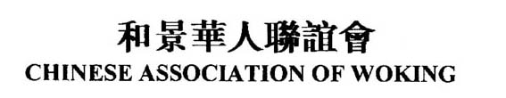
Cookery Lesson on 15 Sept 关于9月15日美食课活动的通知
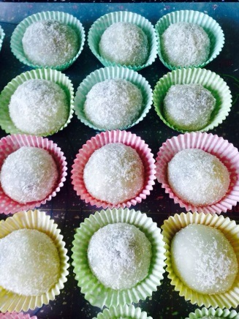
As part of the lottery funded Well Being Activities project, CCP has organised a Cookery lesson on 15th Sept 2015. We are delighted that Mrs Jing Lin, will teach the class how to make colourful Nuomici (a type of Chinese pastry, also known as glutinous rice dumpling). Both members and non-members of the Chinese Association of Woking are welcome.

The lesson is FREE, however the bring-a-dish lunch afterwards is chargeable. Members pay £1, non-members £2. Those who are unable to bring a dish will pay an additional £3 towards the costs of food provided by CCP. If you are interested in attending the class, please contact our CCP co-ordinators, Candy Fisher or Fanhong Kong (email: ccp@cawoking.org.uk).

9月15日CCP将组织由 Big Lottery Fund赞助的美食课。由烹饪高手林静女士在CCP现场教做各色糯米糍主持。热烈欢迎有兴趣的会员或非会员朋友们来参加。

课程是免费的，但接下来的自带一小菜午餐是收费的。会员收费1鎊，非会员2鎊。欢迎大家做点拿手小菜带来共同分享。沒带食物者多付3鎊用于食物原料费用。有兴趣参加者请电联和景华人活动中心負責人Candy Fisher 或孔繁紅ccp@cawoking.org.uk。

Programme节目时间表:
10:30am CCP opens 活动开始
11:00am - 12:30pm Cookery lesson 美食课
12:30pm - 2:00pm Lunch 午餐
2:30pm CCP closes 活动结束
Venue 地点: Old Woking Community Centre, Sundridge Road, Woking, GU22 9AT
