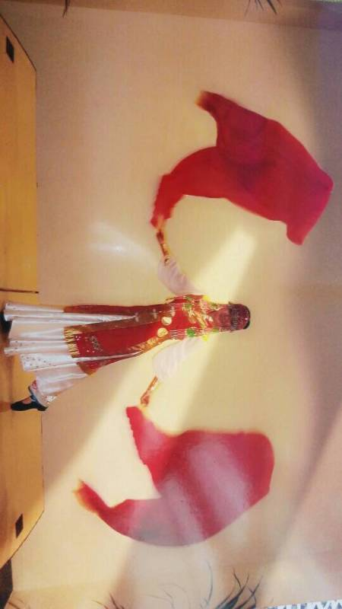
As part of the lottery funded Well Being Activities project, CCP has organised a Chinese Dance lesson on

The lesson is FREE, however the bring-a-dish lunch afterwards is chargeable. Members pay £1, non-members £2. Those who are unable to bring a dish will pay an additional £3 towards the costs of food provided by CCP.

If you are interested in attending the class, please contact our CCP co-ordinators, Candy Fisher or Fanhong Kong (email: ccp@cawoking.org.uk). Both members and non-members of the Chinese Association of Woking are welcome.

10月6日CCP将组织由 Big Lottery Fund赞助的舞蹈课。继续由沈阳音乐学院舞蹈系毕业的杨虹女士, 教大家学跳一首简单易学的中国绸扇舞。有兴趣的朋友欢迎来CCP参加。

课程是免费的，但接下来的自带一小菜午餐是收费的。会员收费1鎊，非会员2鎊。欢迎大家做点拿手小菜带来共同分享。沒带食物者多付3鎊用于食物原料费用。

有兴趣参加者请电联和景华人活动中心負責人Candy Fisher 或孔繁紅ccp@cawoking.org.uk。热烈欢迎有兴趣的会员或非会员朋友们来参加。

Programme节目时间表:

Venue 地点: Old Woking Community Centre, Sundridge Road, Woking, GU22 9AT
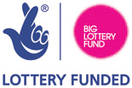
6th Oct 2015. Ms Hong Yang will continue to teach us the basic steps of a Silk Fan Dance routine.
10:30am CCP opens 活动开始
11:00am - 12:30pm Dance lesson 舞蹈课
12:30pm - 2:00pm Lunch 午餐
2:30pm CCP closes 活动结束
Well Being Activities Project – Chinese Dance Class on Tues 6 Oct 2015

